

Topic test 1
Name: __________________________________

Chapter 9: Directed graphs and
networks

- Time allowed: 45 minutes
- CAS calculators may be used.
- Part A: 5 multiple-choice questions (5 marks)
- Part B: 6 short-answer questions (26 marks)
- Part C: 2 analysis questions (20 marks)
Part A
Multiple-choice questions
5 multiple-choice questions
1 mark each: 5 marks
Circle the correct answer.
1 In the digraph shown on the right, a two-stage pathway exists between Y and:
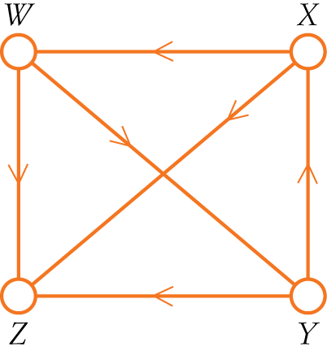
A X only
B Z and X
C W and X
D W and Z
E Z only

[1 mark]
2 The diagram below right shows a section of a network that contains activities E, F, G and H. The activity table for these four activities is:
Activity | 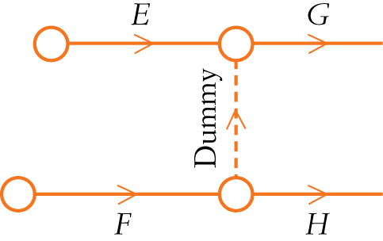Immediate predecessor
G | E, F
H | F
A

B
Activity | Immediate predecessor
G | E
H | F

C
Activity | Immediate predecessor
G | E
H | E, F

D
Activity | Immediate predecessor
G | F
H | E

E
Activity | Immediate predecessor
G | E, F
H | E, F

[1 mark]
Questions 3 and 4 refer to the information below.
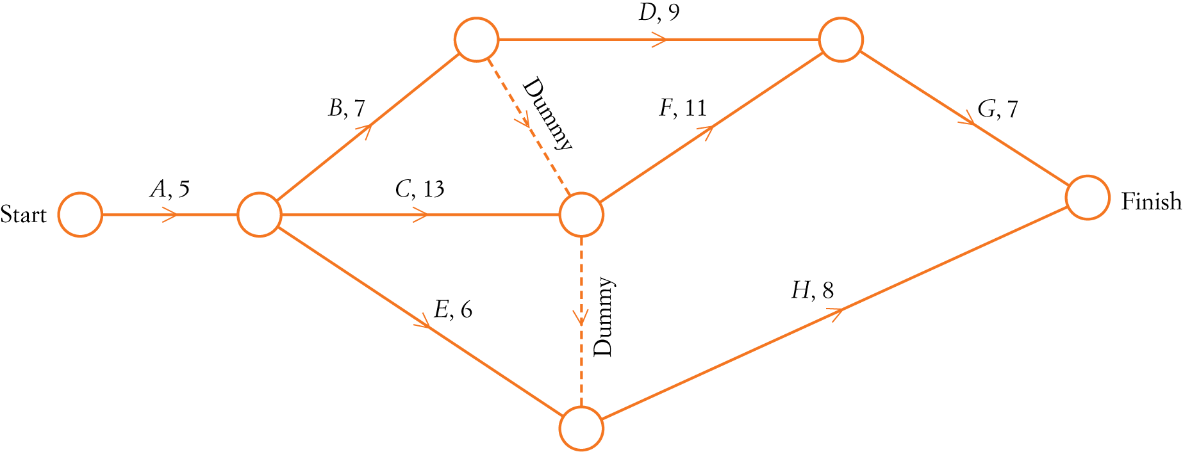
A delivery van is to be repaired. The repair requires every activity in the network below to be completed. Activity times shown are in minutes.

3 The latest starting time for activity H is:
A 18 minutes
B 36 minutes
C 20 minutes
D 11 minutes
E 28 minutes

[1 mark]
4 If activity B is delayed by 8 minutes, repair of the van would be delayed by:
A 8 minutes
B 2 minutes
C 9 minutes
D 0 minutes
E 3 minutes

[1 mark]
5 The bipartite graph at right shows the tasks that Henry, Harriet, Helen, and Harold are trained to complete.
If each person must be allocated one task, a valid allocation is:
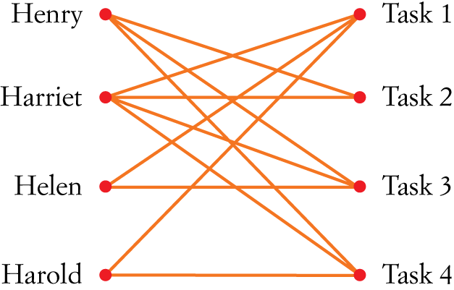
A
Henry | Task 3
Harriet | Task 1
Helen | Task 2
Harold | Task 4

B
Henry | Task 4
Harriet | Task 1
Helen | Task 2
Harold | Task 3

C
Henry | Task 2
Harriet | Task 1
Helen | Task 3
Harold | Task 4

D
Henry | Task 1
Harriet | Task 2
Helen | Task 3
Harold | Task 4

E
Henry | Task 4
Harriet | Task 3
Helen | Task 2
Harold | Task 1

[1 mark]
Part B
Short-answer questions
6 short-answer questions
26 marks
Show your working where appropriate.
1 Draw the network for the activity table below including dummy activities where required.
Activity | Time (hours) | Immediate predecessor/s
A | 6 | None
B | 5 | A
C | 9 | A
D | 8 | B, C
E | 6 | B, C
F | 7 | B
G | 7 | D, E

[5 marks]
2 Calculate the earliest starting times and the latest starting times for each activity in the network below. Activity times shown are in hours.
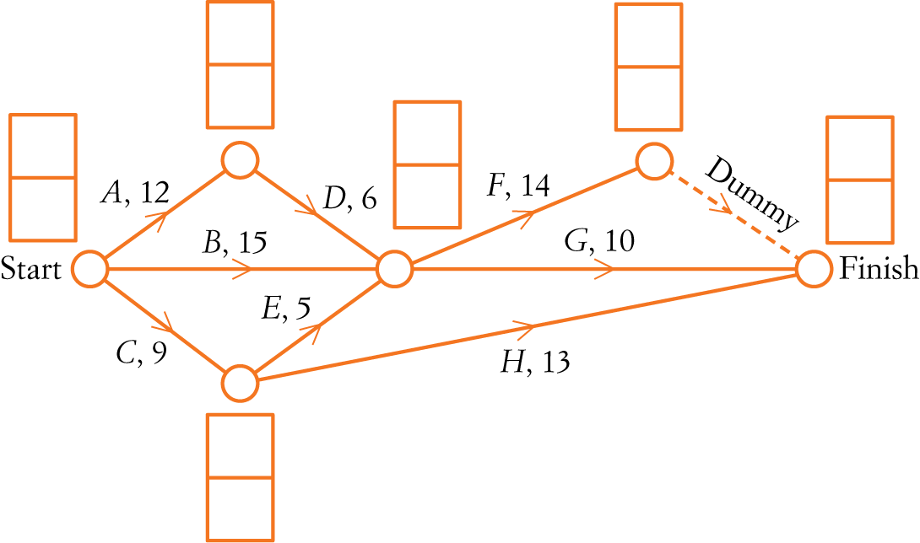

[6 marks]
3 Determine the critical path and the project completion time for the following network. Activity times shown are in days.
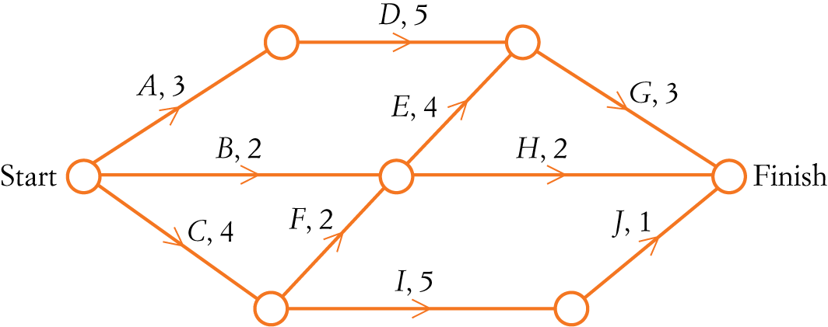

[3 marks]
4 The flow capacity, in cars per minute, for a series of one-way roads is shown in the directed graph below.
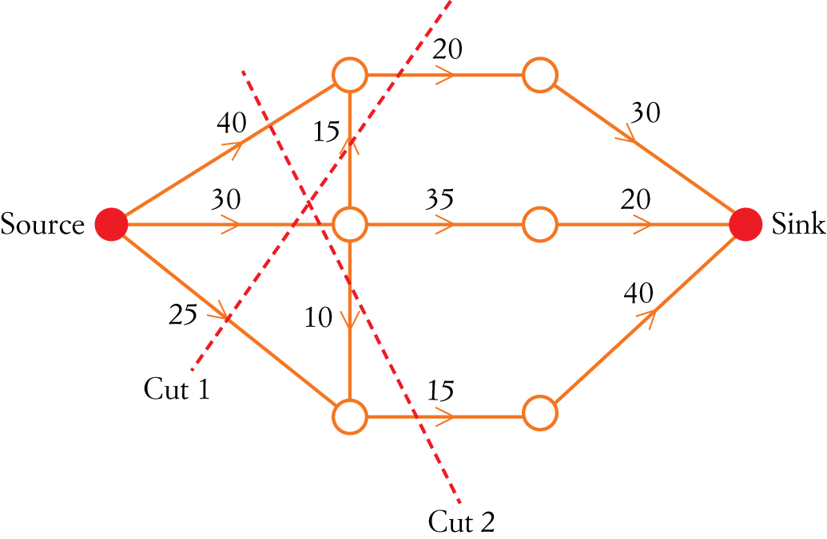

Find:
a the flow capacity of cut 1

b the flow capacity of cut 2

c the maximum flow in cars per minute from source to sink.

[4 marks]

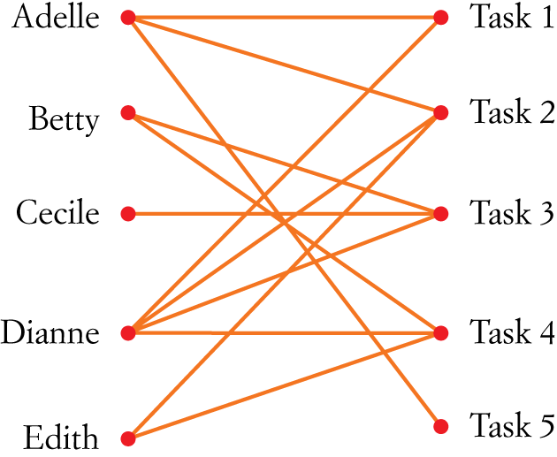
5 Determine the allocation of the five tasks for Adelle, Betty, Cecile,
Dianne and Edith if each person must complete a different task.

[3 marks]
6 Perform row and column reductions on the matrix that represents the time in minutes for Workers
A, B, C and D to complete Tasks 1, 2, 3 and 4. Hence, determine the optimum allocation and the minimum time.
Worker | Task 1 | Task 2 | Task 3 | Task 4
A | 13 | 21 | 15 | 17
B | 20 | 14 | 18 | 12
C | 18 | 15 | 19 | 13
D | 14 | 19 | 17 | 22

[5 marks]
Part C
Analysis questions
2 analysis questions
20 marks
Show your working where appropriate.
1 A furniture store must arrange deliveries to four customers. The store contracts its deliveries to four different drivers. The distance in kilometres that each driver will need to travel to complete the deliveries is shown in the table below.
 | Driver 1 | Driver 2 | Driver 3 | Driver 4
Customer A | 21 | 19 | 26 | 24
Customer B | 15 | 20 | 25 | 21
Customer C | 16 | 22 | 24 | 26
Customer D | 16 | 21 | 27 | 22

The deliveries will be allocated in order to minimise the total distance that must be travelled.
The Hungarian algorithm is to be used to ﬁnd this minimum value.
a Step 1 of the Hungarian algorithm is to subtract the minimum entry in each row from each element in the row.
Complete step 1 for Customer C by writing the missing values in the table below.
 | Driver 1 | Driver 2 | Driver 3 | Driver 4
Customer A | 2 | 0 | 7 | 5
Customer B | 0 | 5 | 10 | 6
Customer C
Customer D | 0 | 5 | 11 | 6

b Complete the Hungarian algorithm so that an allocation can be made.

c Draw the bipartite graph for the final matrix.

d Determine the allocation of drivers to customers.

e Find the total distance travelled by the drivers.

[10 marks]
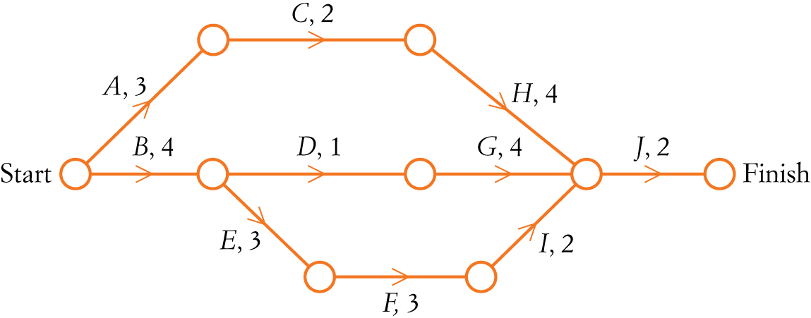
2 A couple decides to remove an old shed from their block and build a new garage. The 10 activities that need to be completed for this project are shown in the network below where activity times are in weeks.
a Find the minimum time required to complete the project.

b Find the float time for activity D.

c Determine the impact on the project completion time if:
i activity C is delayed by 1 week

ii activity G is delayed by 2 weeks

iii activity F is delayed by 2 weeks

iv activity D is delayed by 6 weeks.

The owners are prepared to pay an additional cost to reduce the completion time. The cost of reducing time in each activity is $2000 per week; however, each activity may only be reduced by 1 week.
d Determine the cost of reducing the project completion time by the maximum number of weeks.

[10 marks]
[Total marks: 51]
Answers
Part A – Multiple-choice questions [1 mark each]
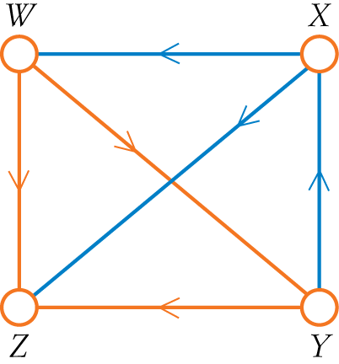
1 A two-stage pathway is a path between two vertices along two edges.
- Two-stage pathways are YXZ and YXW.
- Two-stage pathway is from Y to W and Z.
∴ D
2
Activity | Immediate predecessor
G | E, F
H | F

∴ A
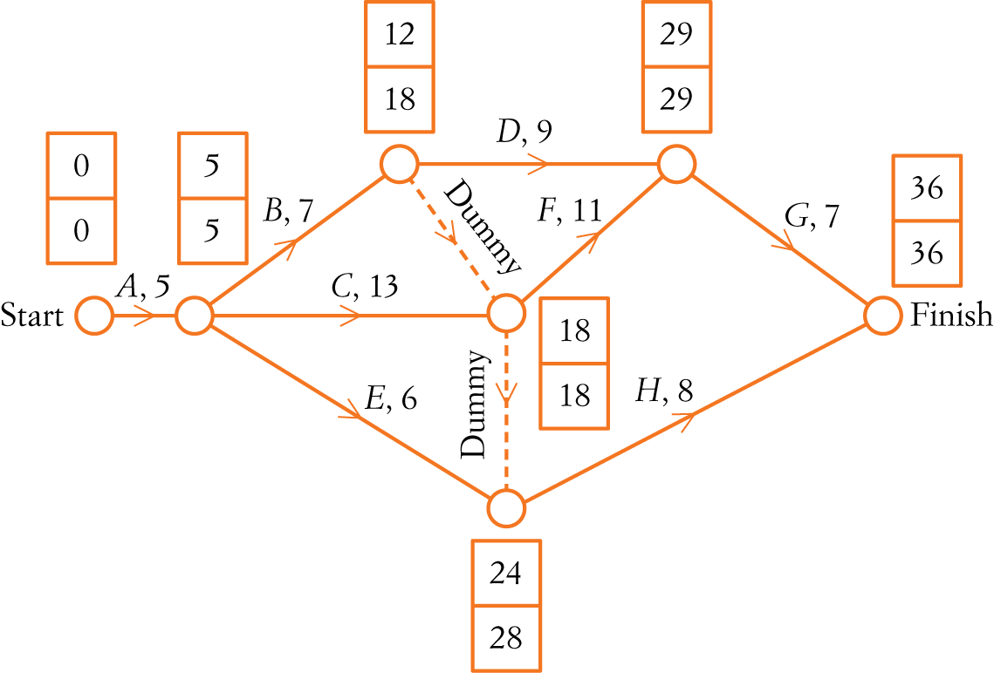
3

The latest starting time for activity H is 28 minutes.
∴ E
4 A delay of 8 minutes in activity B will make the activity time 15 minutes. This creates two critical paths, ACFG and ABDG, but does not affect the project completion time.
∴ D
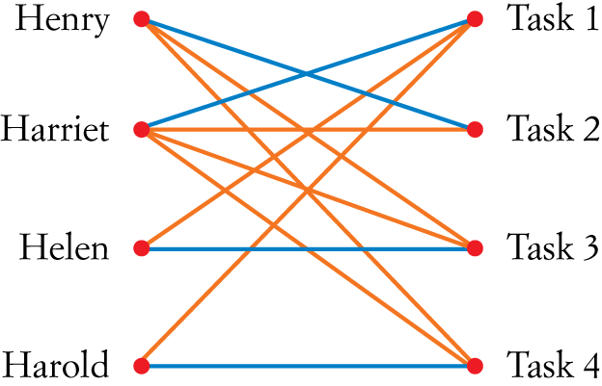
5
Henry | Task 2
Harriet | Task 1
Helen | Task 3
Harold | Task 4

∴ C
Part B – Short-answer questions
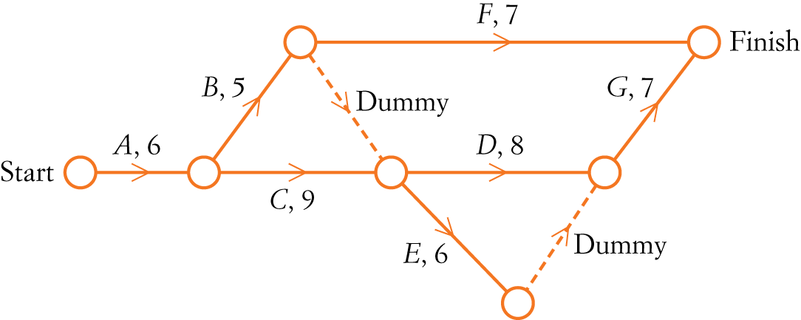
1

[5 marks]
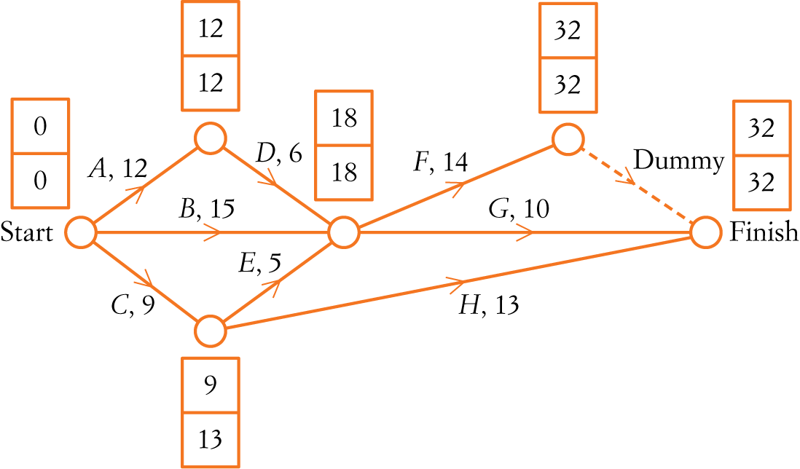
2

[6 marks]
3 Critical path: CFEG
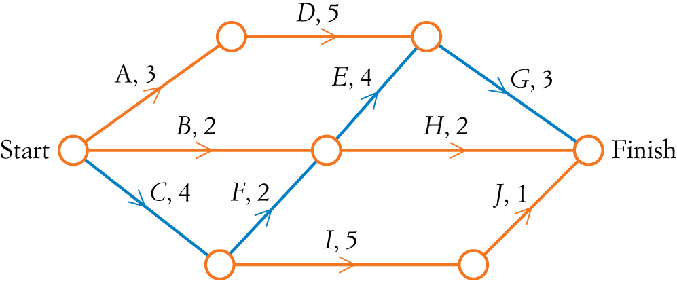

Project completion time = 4 + 2 + 4 + 3 = 13 days.
[3 marks]
4 a Flow capacity of cut 1 = 25 + 30 + 20
= 75 cars per minute
b Flow capacity of cut 2 = 40 + 30 + 15
= 85 cars per minute
c Maximum flow capacity = capacity of the minimum cut
= 30 + 20 + 15
= 65 cars per minute
[4 marks]
5
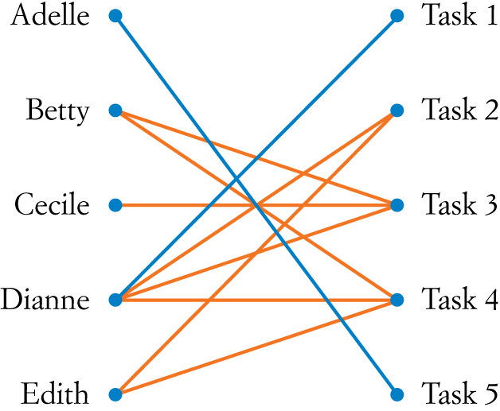
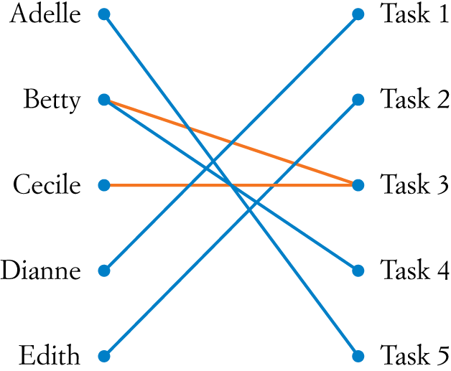

- Adelle must do Task 5 as she is the only person qualified.
- The other lines are now removed from Adelle.
- This leaves Dianne as the only person qualified for Task 1.
- Remove the other lines from Dianne.
- This means Edith is the only person qualified for Task 2.
- The process is continued.
Adelle | Task 5
Betty | Task 4
Cecile | Task 3
Dianne | Task 1
Edith | Task 2
[3 marks]
6 Original matrix Row reduction Column reduction
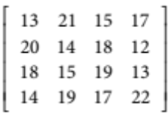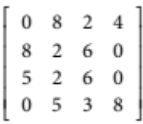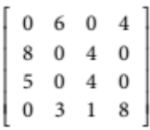
Bipartite graph:
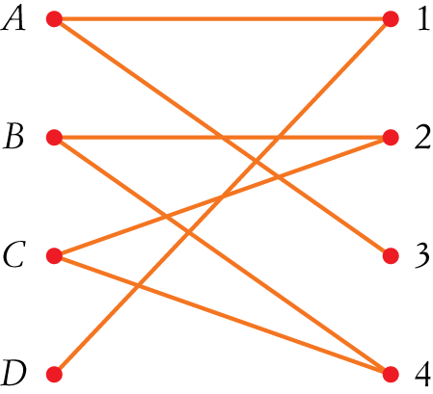

Optimum allocation: A3, B2, C4, D1 or A3, B4, C2, D1
Minimum time: 15 + 14 + 13 + 14 or 15 + 12 + 15 + 14 = 56 minutes
[5 marks]
Part C – Analysis question
1 a
 | Driver 1 | Driver 2 | Driver 3 | Driver 4
Customer A | 2 | 0 | 7 | 5
Customer B | 0 | 5 | 10 | 6
Customer C | 0 | 6 | 8 | 10
Customer D | 0 | 5 | 11 | 6
b Original matrix Row reduction Column reduction
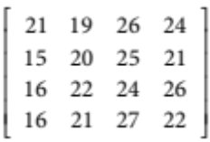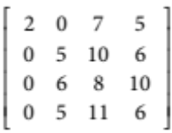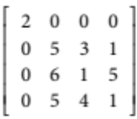
Hungarian algorithm
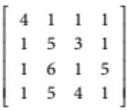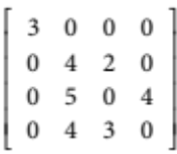
c Bipartite graph
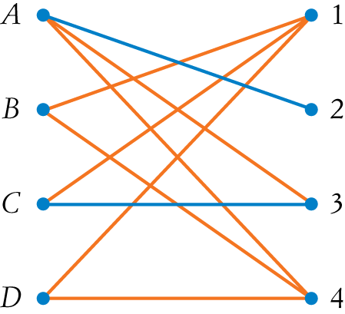

d Allocation of drivers to customers: A2, B1, C3, D4
or A2, B4, C3, D1
e Distance travelled by the drivers:
= 19 + 15 + 24 + 22
or 19 + 21 + 24 + 16
= 80 km [10 marks]
2
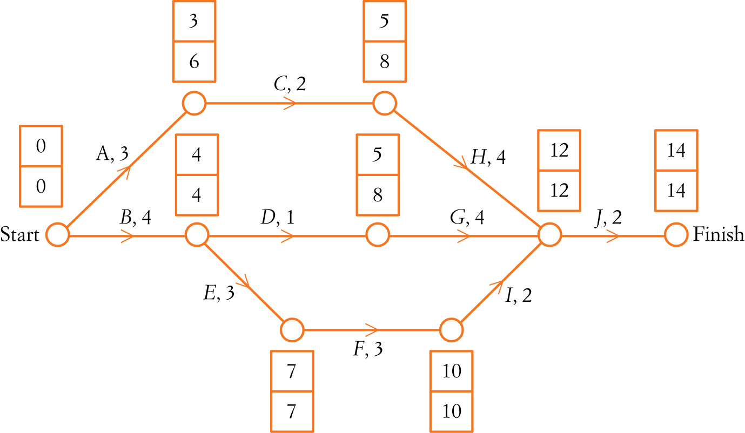

a Critical path: BEFIJ
Project completion time is 14 weeks.
b Float for activity D: 8  4  1 = 3 weeks.
c i If activity C is delayed by 1 week:
float for activity C: 8  3  2 = 3 weeks, so there is no change in the project completion time.
ii If activity G is delayed by 2 weeks:
float for activity G: 12  5  4 = 3 weeks. Therefore, there is no impact on the project.
iii If activity F is delayed by 2 weeks:
activity F is on the critical path, so a delay of 2 weeks will add 2 weeks to the project completion time.
Therefore, the project will be completed in 14 + 2 = 16 weeks.
iv If activity D is delayed by 6 weeks:
float for activity D: 8  4  1 = 3 weeks.
This delay will mean BDGJ is now the critical path.
Project completion time: 4 + 7 + 4 + 2 = 17 weeks.
d Reduce all activities on the critical path by 1 week.
Any reduction in time for non-critical activity does not affect the project.
Cost = 5  $2000 = $10 000.
[10 marks]

